
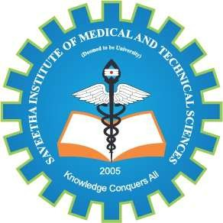
SIMATS ENGINEERING

Saveetha Institute of Medical and Technical Sciences Chennai- 602105

Student Name: G VENKATA GOUTHAM REDDY Reg. No.: 192324265
Course Code: DSA0216 Slot: B
Course Name: Computer Vision with OpenCV for Modern AI
Course Faculty: Dr. Senthilvadivu S &Dr. Kumaragurubaran T

Project Title: Examination of Brain MRI Slices to Detect Alzheimer’s Disease
Module 3: Alzheimer’s Disease Stage Analysis & Report Generation
Module Photographs: (3 photographs –Module Photo, Individual student contribution module work in the project and presentation image)
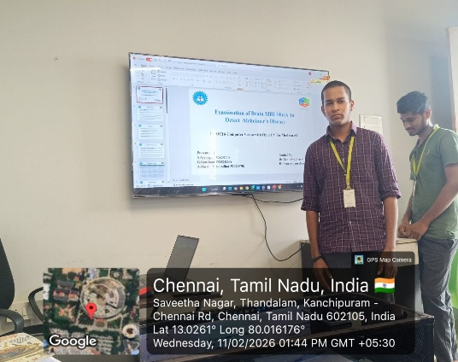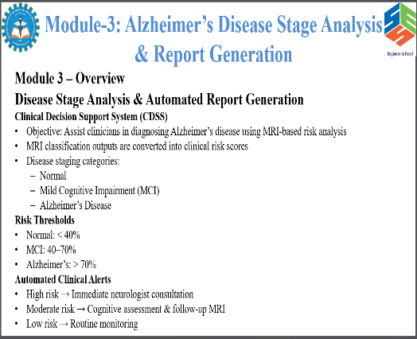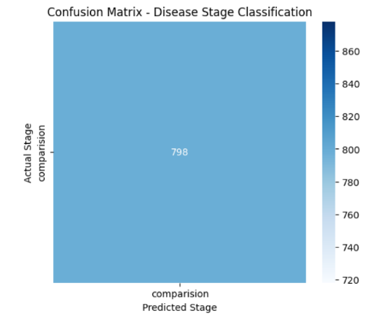
Project Description: (here you write what you did in this project (contribution) including Model
Description
Alzheimer’s Disease Stage Analysis & Report Generation is the final module of the system where the predicted results from MRI image classification are analyzed to determine the stage of Alzheimer’s disease. After preprocessing and classification, the model categorizes patients into stages such as Normal, Mild Cognitive Impairment (MCI), or Alzheimer’s Disease. Based on these predictions, clinical insights such as risk level, disease severity, and progression indicators are generated. The system then prepares a structured report containing patient details, predicted stage, confidence score, and recommended medical guidance. This report helps doctors and healthcare professionals in making accurate decisions, monitoring disease progression, and planning appropriate treatment strategies. In this module, the classification results are converted into meaningful clinical insights. Finally, a detailed and structured report is generated that includes patient information, MRI analysis summary, predicted stage, confidence level, and possible medical recommendations.

Student Signature Guide Signature

